Project Phase 0: Proposal

### Proposal Overview

In this phase, your task to define the scope of a networked Android app. This will take the form of a list of features and a set of wireframes.

### Coming Up With an Idea

First, decide on a broad topic and name for your app. You can choose any business you can think of, or even choose a topic that no business would ever want. If you are having trouble, pick an app that you use on a day to day basis and build your proposal based off its features.

This proposal will dictate the nature of your entire project, so choose it with care!

### Deciding on Features

After you have decided on a topic, you must determine the scope of your project. Choose a scope that you will find challenging, but doable. You do not need to implement the features with code at this step of the project-- you just need to describe them in plain English. Your project features must include, at minimum, the following:

1. At least three screens with substantial user interaction.
2. Data that is persisted locally.
3. A networked connection to and/or from the application. For example,
   1. Networked Google services such as Places.
   2. Third party APIs.

If you are having trouble listing your features, consider creating them as user stories. A user story is a one or two sentence description of a feature from the perspective of what a user might want to do. For example, if your application is a grocery shopping list, your user stories might be something like:

* As a user, I want to have a login screen.
* As a user, I want to see an animated weather summary for my current location.
* As a user, I want to be able to see a 14 day weather forecast.
* As a user, I want to receive a notification with the current weather when I wake up.
* As a user, I want to be able to set my preferences for notifications.

### Creating Wireframes

A wireframe is a very rough approximation of a screen. As the focus of this course is not design, you do not need to follow standard wireframing conventions.

Typically, a set of wireframes is handed off from a designer to a developer at the beginning of a project. It should include enough information to describe the information in each menu, window, and dialog. It does not include, colors, fonts, styles, or any artistic information.

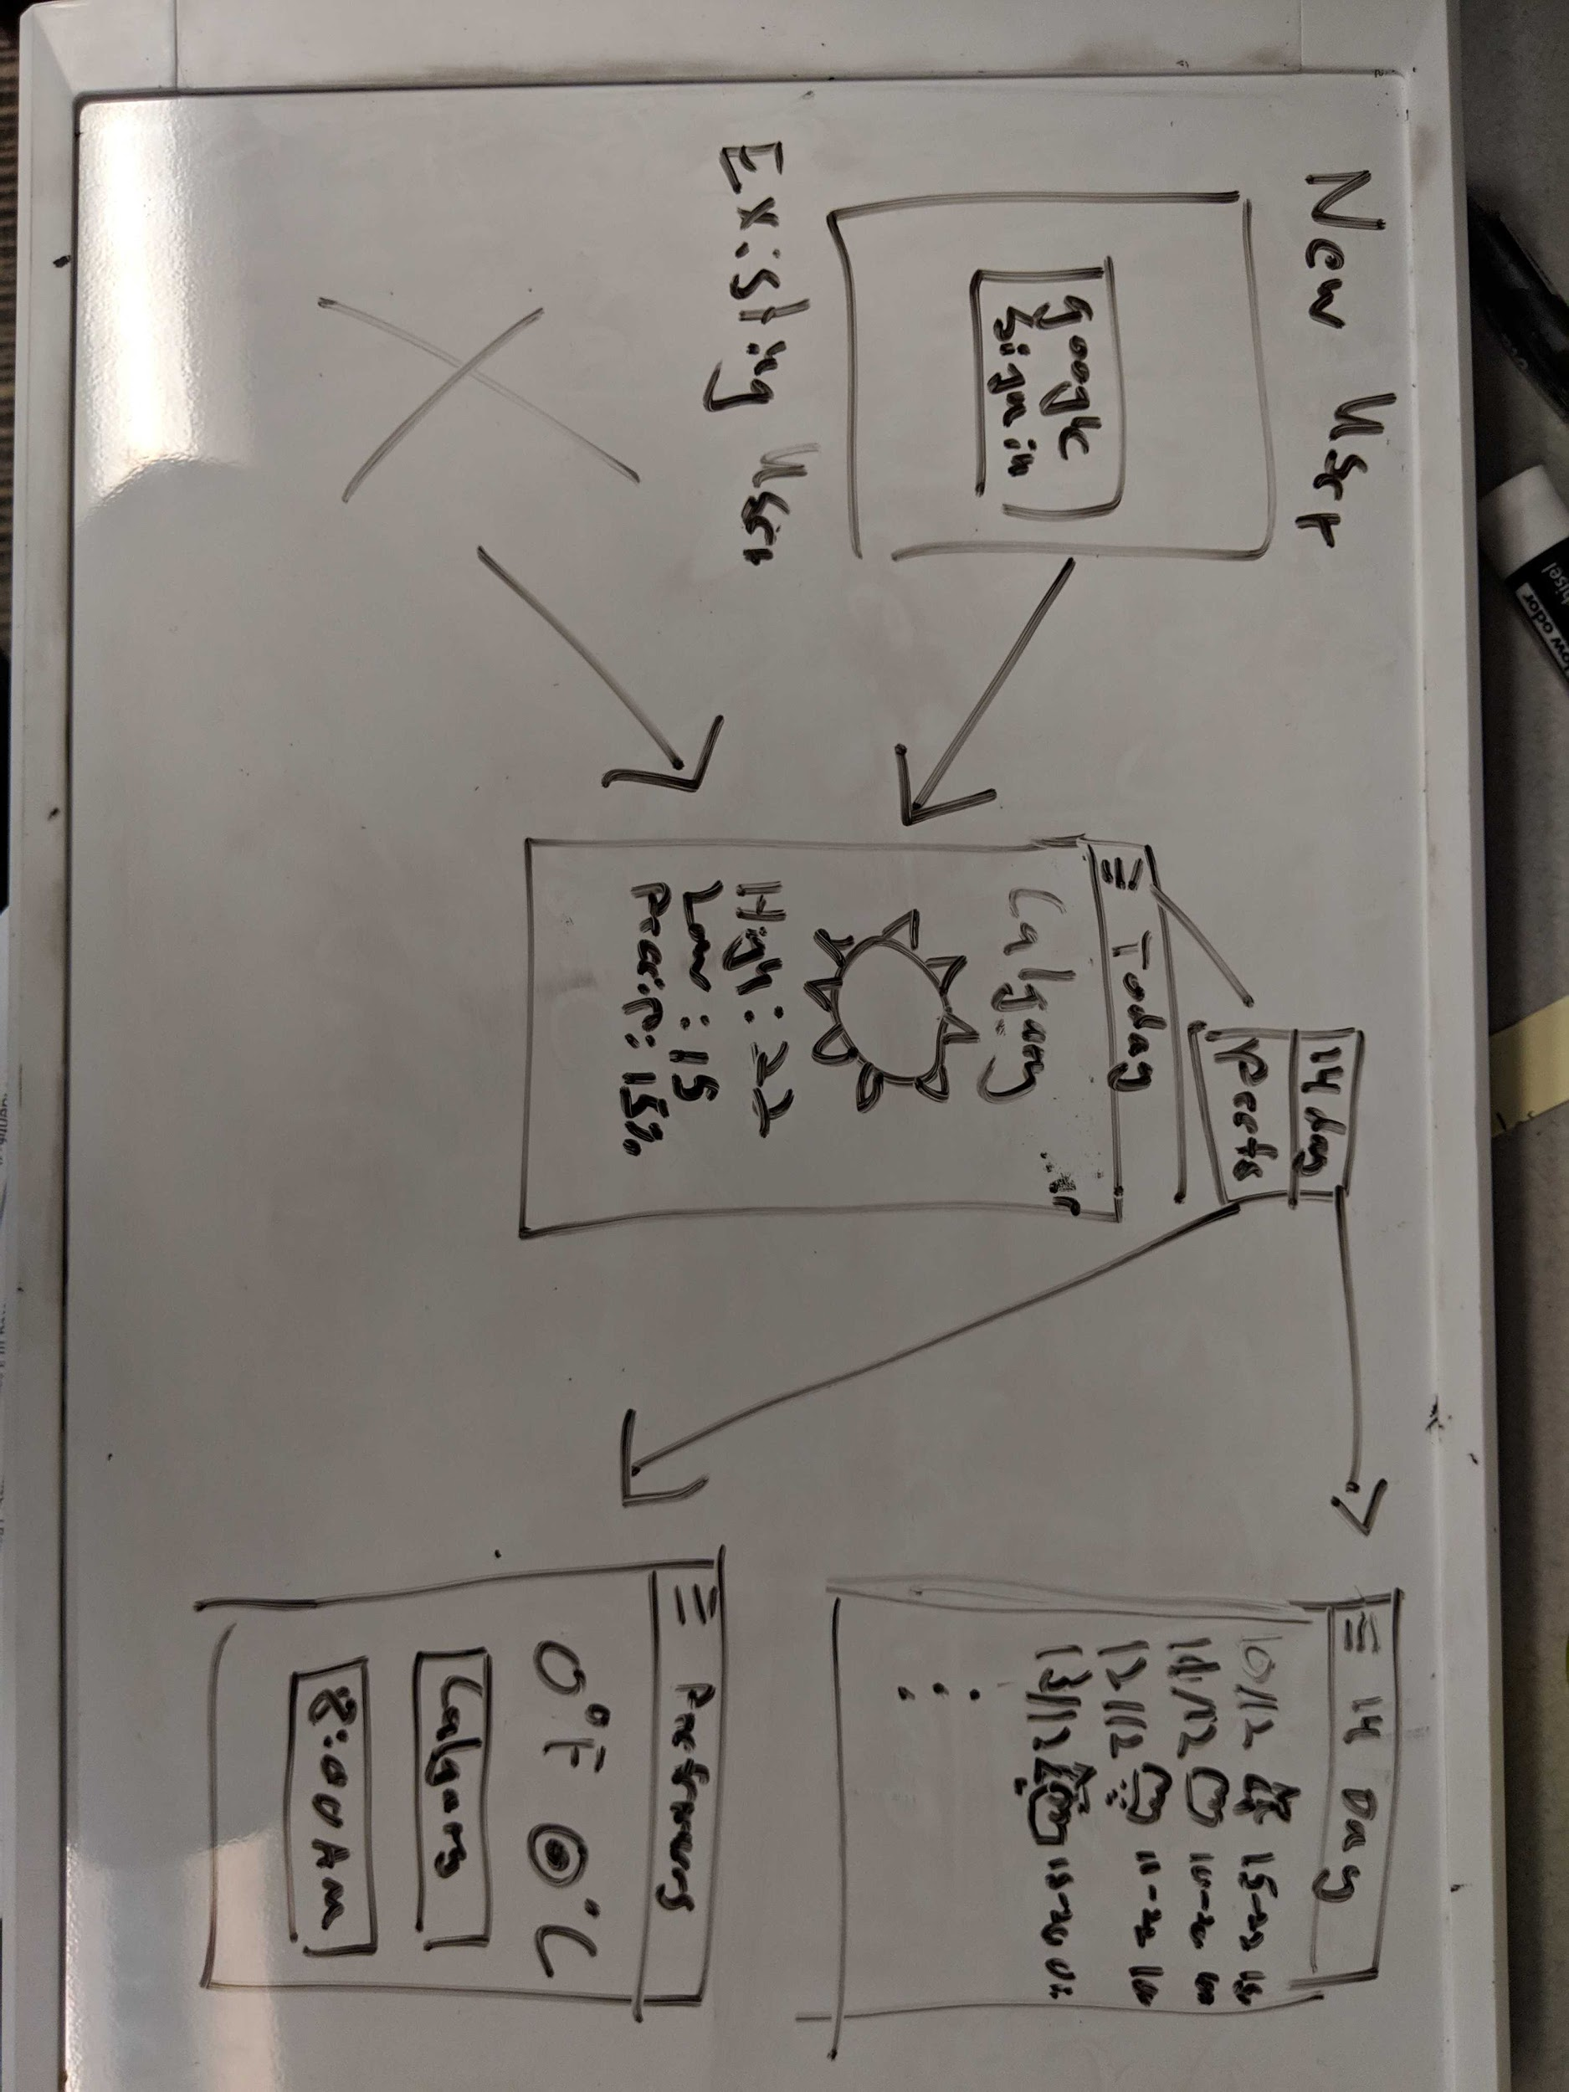

This example demonstrates what our weather app might look like. It has a login screen, a screen for today’s forecast, a screen for a 14-day forecast, and an account preferences screen. Navigation is accomplished through a hamburger button menu. This wireframe is sufficiently detailed to build layout files, but it is not particularly aesthetically pleasing.

When possible, you should try to use Google’s material design guidelines: <https://material.io/design/>

Your sketch can be hand drawn, as above, or created using a tool such as <https://wireframe.cc/>.

### Submission Requirements

Your proposal should be submitted as a merge request on your repository as normal. All proposal documents should be contained within a proposal folder in that repository. Send me an invite link (d2l submission) to your repository.

### Marking Criteria

Your instructor will review your project proposal, and may add or remove requirements as necessary. You should update your proposal time to time based on the feedback or as per you learn new topics. Keep all the changes in your commit history. The proposal will carry 20% of the marks allocated in PRJ_Part-01.